ASSIGNMENT DAY 3

* Creating instance of Windows Machine:

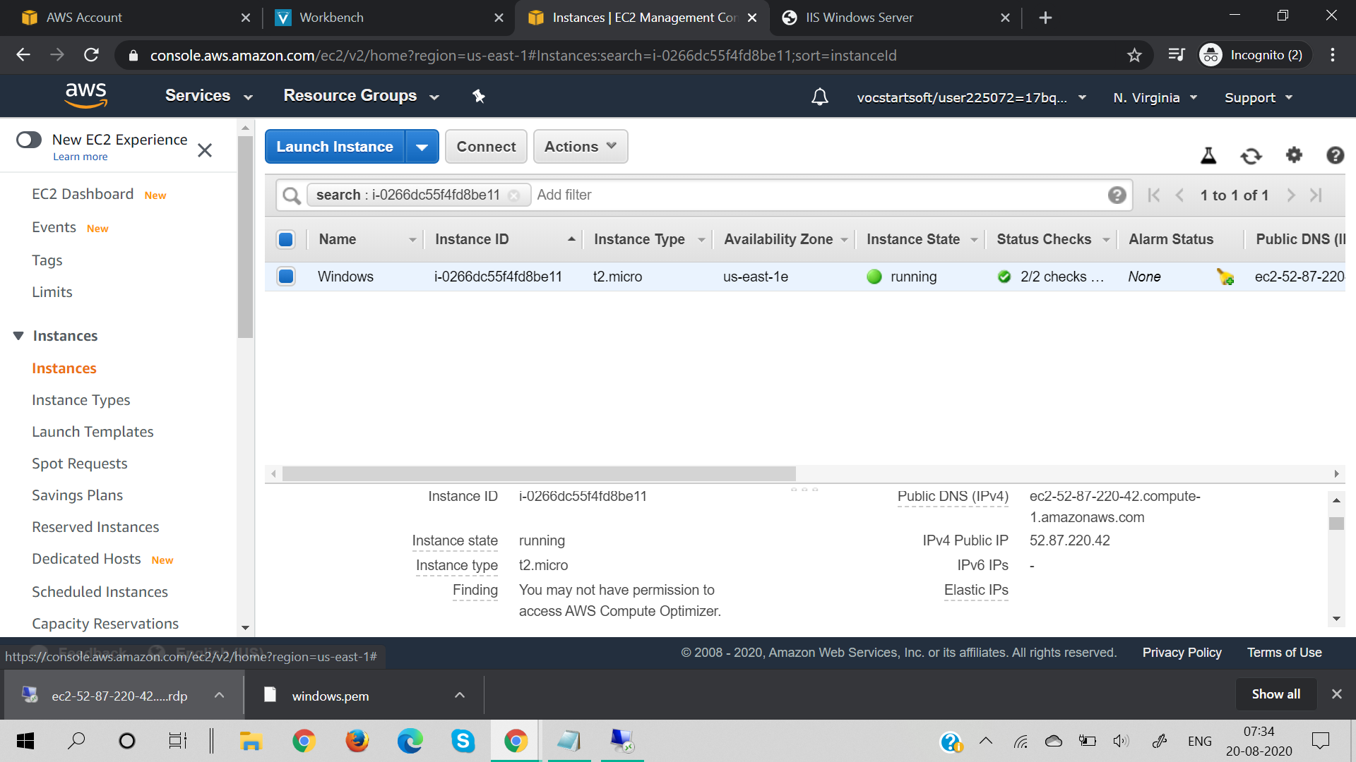

* IIS Windows Server:

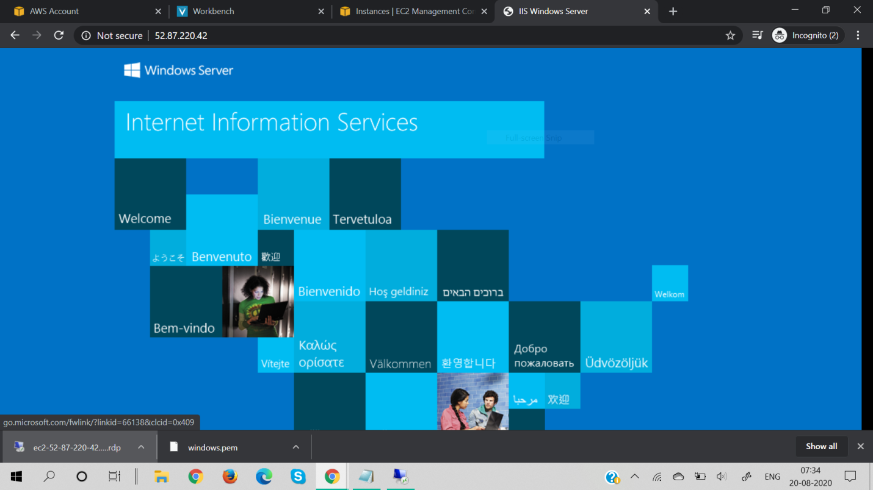

* Creating instance of Ubuntu Machine:

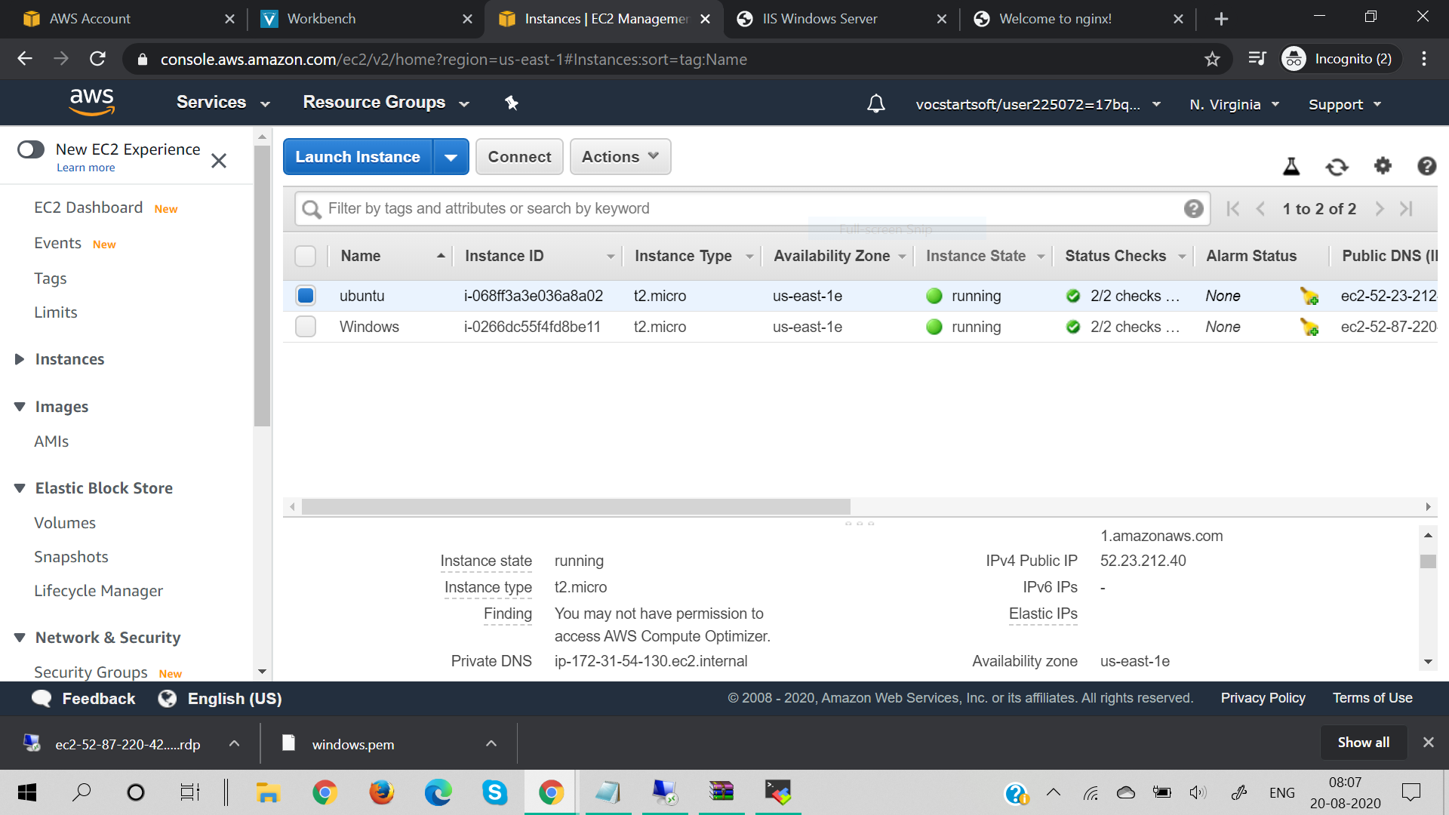

* Nginx web Server:

